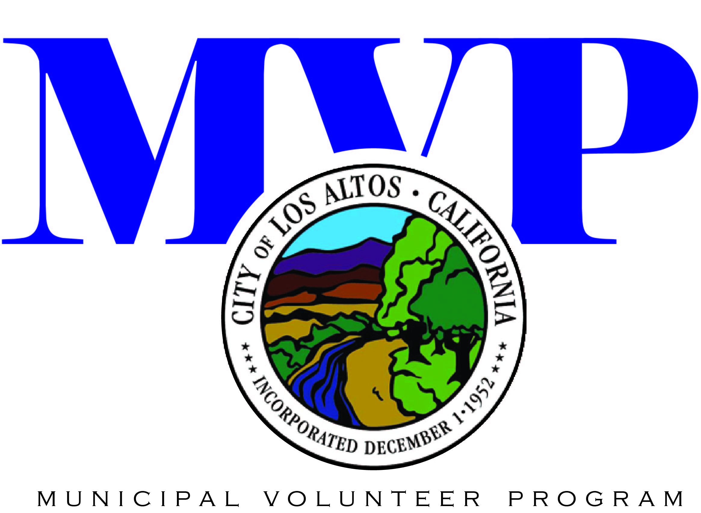 Parental Permission Form
For volunteers under the age of 18

The City of Los Altos welcomes volunteers aged 13 and above. Volunteers play a vital role in many City programs and activities. The City requires that volunteers under the age of 18 provide written permission of a parent or their legal guardian in order to volunteer.

Please complete and sign this form, obtain your parent or guardian’s signature on the form, and return the form to the Los Altos Community Center 97 Hillview Avenue, Los Altos, CA 94022.

If you have any questions, please contact the Los Altos Parks & Recreation Department at (650) 947-2790 or email recreation@losaltosca.gov.

- I am the parent or legal guardian of the above named minor child and give permission for my child to volunteer for the Los Altos Parks and Recreation Department.

- I give the City of Los Altos permission to use any photographs or videos made of my child during their service without obligation or compensation to me.

- I understand that my child will be covered as a volunteer under the City’s Worker’s Compensation program for any injury or accident while on duty.

___
Volunteer Name (please print) Volunteer Position or Event
___
Signature of Volunteer Date

Name of Parent (please print)

___
Signature of Parent/Guardian Date

Volunteer Supervisor: (1) Please provide this form to the volunteer prior to the event. (2) Ask the volunteer to read this form with their parent or legal guardian, complete and sign. Minors must obtain parent signature. (3) Send a copy of the form to MVP for filing. If you have questions, please contact the Los Altos Parks & Recreation Department at (650) 947-2790.

