MAP OF VETERINARIANS, GROOMERS & PET FRIENDLY HOTELS
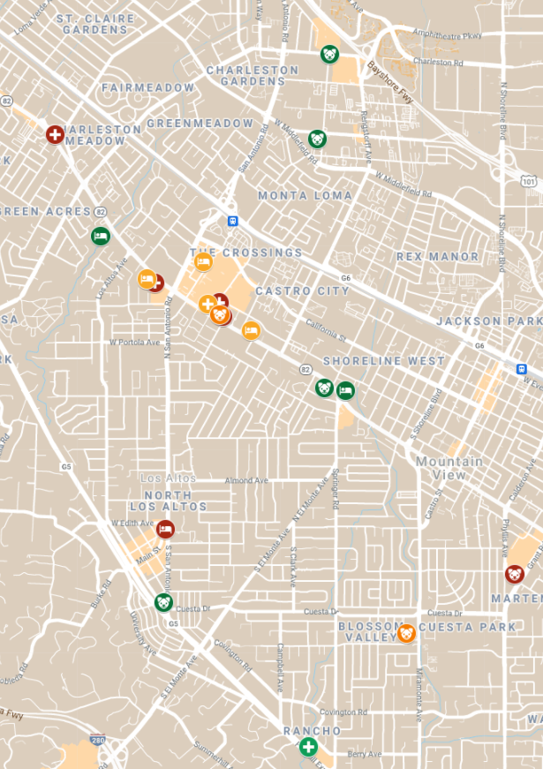
VETERINARIANS  Adobe Animal Hospital  4470 El Camino Real, Los Altos, Ca 94022  Phone Number: 650-948-9661  Alpine Animal Hospital  2460 W. El Camino Real, Mountain View, CA 94040  Phone Number: 650-969-8555  Alta View Animal Hospital  690 Showers Drive, Mountain View CA 94040  Phone Number: 650-948-1021  Animal Hospital of Palo Alto  4111 El Camino Real, Palo Alto, CA  Phone Number: 650-493-2738  Cherry Chase Pet Hospital Veterinary in Sunnyvale  1297 W El Camino Real Ste D, Sunnyvale, CA 94087  Phone Number: 650-961-4550  Los Altos Veterinary Clinic  1150 Riverside Dr, Los Altos, CA 94024  Phone Number: 650-948-8287  MedVet Mountain View  601 Showers Drive, Mountain View, CA 94040  Phone Number:650-494-1461  Midtown Veterinary Hospital  3045 Middlefield Rd, Palo Alto, CA 94306  Phone Number: 650-397-7387  Miramonte Veterinary Hospital  1766 Miramonte Ave, Mountain View, CA 94040  Phone Number: 650-962-8338  South Bay Animal Hospital and Pet Resort  5188 Moorpark Ave, San Jose, CA 95129  Phone Number: 408-899-4791  Sunnyvale Veterinary Clinic  1036 El Camino Real, Sunnyvale, CA 94087  Phone Number: 408-736-8296  VCA Palo Alto Animal Hospital  3944 El Camino Real, Palo Alto, CA 94306  Phone Number: 650-493-4233 | PET FRIENDLY HOTELS  Hyatt Centric  409 San Antonio Rd, Mountain View, CA 94040  Phone Number: 650 948 1234  Pet Fees: $0 They don’t charge any pet fees  Surestay Plus Hotel By Best Western  2300 W El Camino Real, Mountain View, CA 94040  Phone Number: (650)-962-9912  Pet Fees: $50 fee for any pet  Crowne Plaza  4290 El Camino Real, Palo Alto, CA 94306  Phone Number: 1 877 227 6963  Pet fees: $50 for cats and dogs up to 50lbs  Enchante Boutique Hotel  1 Main St, Los Altos, CA 94022  Phone Number: (650) 946-2000  Pet fees: $30 for any animal  Residence Inn by Marriott Palo Alto Mountain View  1854 El Camino Real West, Mt View, CA 94040  Phone Number: 650 940 1300  Pet fees: $75 (they only accept dogs)  GROOMERS  Barking Lot  385 1st St, Los Altos, CA 94022  Phone Number: 650-949-1870  Critter Clippers Pet Grooming Salon and Boutique  1350 Grant Rd Suite 12, Mountain View, CA 94040  Phone Number: 650-961-4661  Grooming Works  2464 W El Camino Real A2, Mountain View, CA 94040  Phone Number: 650-948-9230  Pet Parlor (formerly Heidi’s Dog Grooming)  2423 Old Middlefield Way, Mountain View, CA 94043  Phone Number: 650-966-1303  Petco Grooming  1919 El Camino Real, Mountain View, CA 94040  Phone Number: 650-966-1233  PetSmart  2440 E Charleston Rd, Mountain View, CA 94043  Phone Number: 650-968-1034

