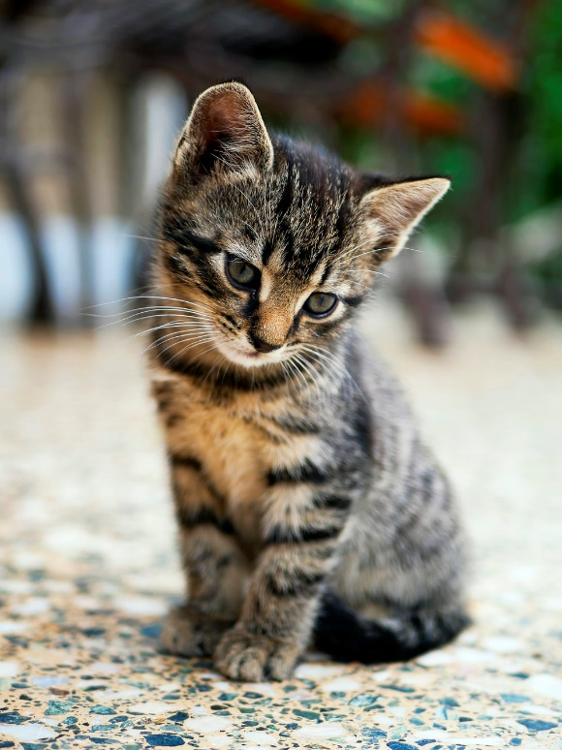

Take the time to fill in this Disaster Preparation form in case you lose your pet, or if you need to pass your pet to a friend in an emergency.

Pet Name: ______________

Age / DOB: _____________

Breed: _________________

Color: _________________

Gender: _______________

Weight: _______________

Microchip #: ____________

License #: ______________

Allergies: ______________

______________________

**Hi! This is My Information:**

**OWNER’S INFORMATION**

Your Name: ____________________________________

Your Address: __________________________________

Your Phone Number: _____________________________

Email Address: _________________________________

**FOOD & MEDICATIONS**

Type of food: __________________________________

Brand of food: _________________________________

🞎 Wet 🞎 Dry 🞎 Wet & Dry

Amount: _____________ Frequency: ________________

Name of Medication #1: __________________________

Instructions #1: ________________________________

_____________________________________________

Name of Medication #2: __________________________

Instructions #2: ________________________________

_____________________________________________

**MEDICAL INFORMATION**

Veterinarian Name: ______________________________

Veterinarian Phone: ______________________________

Date of last rabies vaccine: ________________________

Rabies Certificate #: ____________________________

Date of last Bordetella vaccine: _____________________

Date of last FVRCP vaccine: ________________________

Date of last FeLV vaccine: ___________________­­______

Date of last FIV/FIP vaccine: ______________________

Current medical conditions: ________________________

Behavior concerns: ______________________________

_____________________________________________